DFN DRZ of the Environment – Application Form

The Educating Towards Change Society (ETC) invites environmental activists aged 13 -15 to apply for a one week all expenses paid Environmental Action Camp on Denman Island, BC

We will spend one week, from August 20th - 27th creating compelling media - music, drama, documentary, and dance, all with a focus on defending the environment.

Interested? Complete the application form below and send it in by mail or email. Make sure you show you are PASSIONATE about the Environment and have some IDEAS you want to create and share with the World. The camp is limited to 16 spaces, so we are truly looking for motivated applicants!
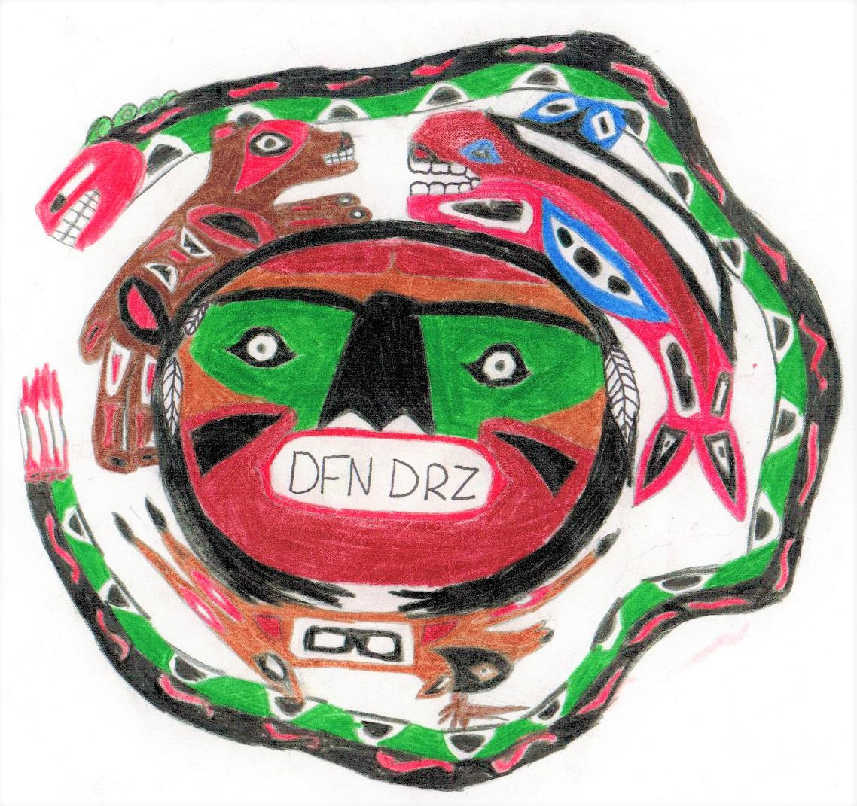
THE CUTOFF FOR SUBMISSIONS IS JUNE 30!

Name: | Age: | School:
Address:

Telephone: |  | Email/Facebook Page:
please turn over…
Why would you like to participate?

What ideas would you like to develop?

What skills do you bring to the table? (Drama, music, film, writing, ideas…)

By mail: Daniel Farrow
3226 Kirk Road
Denman Island, BC
V0R 1T0

By email: danieljonesfarrow@gmail.com

https://www.facebook.com/EnvironmentDFNDRS/

http://www.etcsociety.ca/current_projects.html

